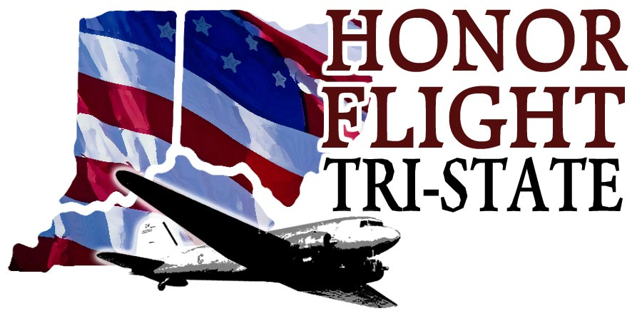

Headquarters
8627 Calumet Way ● Cincinnati, OH 45249 ● 513-489-2022
www.honorflighttristate.org

“MAIL CALL PROGRAM”

Honor Flight Tri-State is seeking your help! Anyone who belongs to a group, is affiliated with a school, scouts, etc. may participate.

Our mission is to fly our Veterans age 65 and over to Washington, DC to see their memorials. Veterans fly FREE in birth year order with WWII Veterans or terminally ill Veterans receiving priority. We fly four times each year; April, May, September and October and host 87 Veterans and their guardians on each flight.

Honor Flight is a non-profit, all-volunteer organization that raises the necessary funds to fly our Veterans, and often this trip is the “Welcome Home” and “Thank You” that our Veterans never received.

One of the highlights of the trip is the “Mail Call” Program. Each Veteran receives a large envelope filled with various types of Welcome Home and Thank You cards, letters and notes. We are asking you to participate in this program with us. Letter, cards and notes from students - “Our Young Patriots” - are especially meaningful and always make the Veterans smile and cry! We continually hear Vets say, “I didn’t know anyone cared about us.”

During their war/service time, many Veterans did not have of the modern communication devices available to service members today. There was no facetime, text, instant messaging, emails, tweets, etc. All communication was by snail mail. Mail, if delivered at all, came off the boat and took 30 – 60 days to be delivered to the GI’s.

“Mail Call” is an institution in the military. Receiving a card, letter or package from home was a long awaited and anticipated emotional moment. A GI would hold the letter and look at it, smell it and try to find a quiet place to sit down and read it. They would reread it multiple times. It helped them get through their day.

If you are interested in participating in our Mail Call Program, please review the following information. Many schools use this project in Art, English and History classes as a teachable moment.

Please mail the Mail Call items to the above address OR you can call us and we will pick them up. If you are interested, we may be able to make an informational presentation to your school or individual classes about Honor Flight Tri-State.

We need about 1500 – 1800 pieces of mail each year and we are very low this year.

Some key phrases that might be incorporated into your cards, letters drawings and notes:

Thank you for Your Service
Thank you for Your Sacrifices
Welcome Home Veteran
Our Veterans are the greatest American Heroes
We hope you enjoyed your Honor Flight Experience
We love our Veterans
We appreciate all that you have done for us!
Where would we be without our Service Men and Women
We should THANK our Vets everyday but today is a special day for you
Congratulations on a job well done
We honor America by honoring our Veterans
Thank you for defending our freedoms

Resources to learn more about Honor Flight Tri-State: www.honorflighttristate.org;
Honor Flight-The Movie (found on our website).

You can find Patriotic clip art on websites. Multiple copies of the same letter can be made and then individually signed.

Some general dos and don’ts when writing cards and letters to the Honor Flight Veterans:

- Keep it short and to the point.
- Express your gratitude and appreciation (see list of key phrases).
- Your mail may be given to either male or female Veterans so keep it gender neutral, i.e., “Dear Veteran”.
- We fly any Veteran over the age of 65 so we may have WWII, Korean, Vietnam and/or Cold War Veterans on our flights. Please keep it service and time frame generic.
- (children) Please avoid references to violence in your wording or drawings. Avoid blood, bodies, bombs, explosions, etc. Concentrate on the Patriotic Symbols such as our flag, our “red, white and blue” colors, the American Eagle or other national symbols.
- Please sign your letters with your first name only.
- You may include your school or organization name.
- Please do not date your mail call items as we have four flights each year. We do not know which flight will carry your mail.

The Mail Call team thanks you for your interest and support of our Veterans!

Pam Recklehoff
preckelhoff@aol.com

